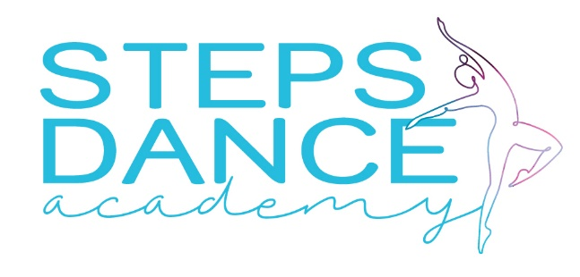

stepsdanceacademyofficial@gmail.com melodyralph@live.com
STUDIO: 066 265 6961 MELODY: 0823026880
DANCER’S INFORMATION

FULL NAME OF STUDENT
STUDENT’S DATE OF BIRTH
STUDENT’S ID NUMBER
STUDENT’S CONTACT NUMBER
MEDICAL CONCERNS

STYLES REGISTERED FOR 2026 |  | EVENTS FOR 2026
BALLET | YES / NO | EXAMS | YES / NO
MODERN (CONTEMPORARY/JAZZ) | YES / NO | EISTEDDFOD | YES / NO
HIP HOP | YES / NO | SHOWS AND PERFORMANCES | YES / NO
ACRO (DANCE / SPORT) | YES / NO | COMPETITION TEAM | YES / NO
TAP | YES / NO | JUST FOR FUN | YES / NO
CHEER LEADING | YES/NO

PARENT / LEGAL GUARDIAN INFORMATION

 | MOTHER | FATHER
FULL NAME OF PARENT/GUARDIAN
CONTACT NUMBER
EMAIL

PERSON RESPONSIBLE FOR TUITION FEES

FULL NAME
ADRESS
ID NUMBER
CONTACT NUMBER
EMAIL

STUDIO POLICIES

SIGNATURE | Please acknowledge that you have read and understood the following
 | I, as parent / legal guardian hereby concur, and agree to defend, indemnify, and hold guiltless Steps Dance Academy, from and against all liability, loss, damage, claims, or actions (including attorney fees) for bodily injury and /or property damage to the extent permissible by law, arising out of, or in connection with Steps Dance Academy competitions, properties, facilities and / or services
 | I undertake not to participate in any defamation of character regarding Steps Dance Academy on any platform
 | I undertake to approach the management of Steps Dance Academy personally should I have any queries
 | A Non-refundable annual registration fee of R200 p.p / R250 p.family is payable with registration
 | All fees are payable for a full month, regardless of when student register
 | All fees are payable in advance on the 1st of each month / 1st lesson of each term
 | There will be a 10% penalty fee on all overdue payments
 | Normal monthly tuition fees are payable for December and school/public holidays
 | There are no classes during Public School Holidays
 | Tuition fees do not include fees for exams, competitions, and other costs
 | ONE TERM written notice is required for cancellation of classes
 | Parents and siblings are allowed in the studio but must be respectful and quiet
 | Please adhere to the policy and guidelines of the Popia act with regards to sharing of videos and photos of dancers on social media. This is to protect the dancers’ privacy, maintain professional [ standards, and adhere to copyright laws. If you have questions about this policy, feel free to ask

FEE STRUCTURE

PLEASE CHOOSE ONE OPTION
MONTHLY X 12 MONTHS |  | PER TERM X 4 TERMS
MONTHLY – 1 STYLE – R 375 |  | PER TERM – 1 STYLE – R 1050
MONTHLY – 2 STYLES – R 700 |  | PER TERM – 2 STYLES – R 1950
MONTHLY – 3 STYLES – R 900 |  | PER TERM – 3 STYLES – R 2500
MONTHLY – 4 STYLES – R 1050 |  | PER TERM – 4 STYLES – R2750
MONTHLY – ALL STYLES – R 1350 |  | PER TERM – ALL STYLES – R 3000

POPIA

Steps Dance Academy reserves the right to use photographs and videos taken during class, workshops, performances, or other affiliated events for the purpose of instruction, advertising and promoting.
Students or Parents of minors who do not wish to comply with this policy must notify Steps Dance Academy in writing

_____________________________ ______________________
Signed Date

